Question 1: Student Notes Manager (CRUD Operations)
Develop a simple web application that allows students to create, view, update, and delete study notes stored in MongoDB.
Modules
- Add Note
- View Notes
- Edit Note
- Delete Note

Functional Requirements
1. Add Note
Student enters:
- Title
- Subject
- Description
AJAX sends JSON data to server.
Example JSON request:
{
"title":"MongoDB Basics",
"subject":"Database",
"description":"Introduction to MongoDB concepts"
}
MongoDB stores document in notes collection.
Example MongoDB document:
{
"_id":"ObjectId",
"title":"MongoDB Basics",
"subject":"Database",
"description":"Introduction to MongoDB concepts",
"created_date":"2026-03-05"
}
2. View Notes
Display all notes stored in database.
AJAX request:
GET /notes
Server returns JSON:
[
{
"title":"MongoDB Basics",
"subject":"Database",
"description":"Introduction to MongoDB concepts"
}
]
Frontend dynamically renders notes using JavaScript.
3. Update Note
Student can modify title or description.
AJAX request:
PUT /notes/{id}
{
"title":"MongoDB Advanced",
"description":"Aggregation and indexing"
}
MongoDB operation:
db.notes.updateOne(
{_id:ObjectId(id)},
{$set:{title:"MongoDB Advanced",description:"Aggregation and indexing"}}
)
4. Delete Note
AJAX request:
DELETE /notes/{id}
MongoDB query:
db.notes.deleteOne({_id:ObjectId(id)})

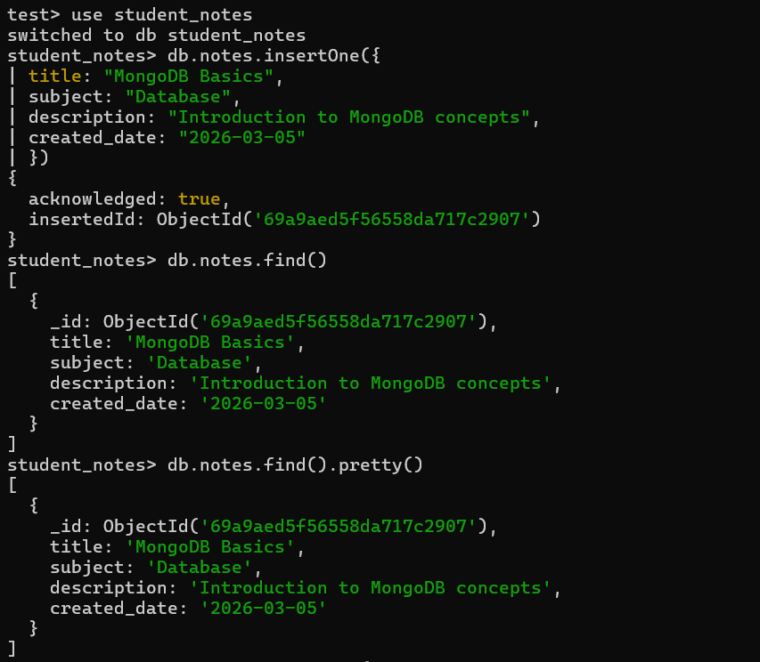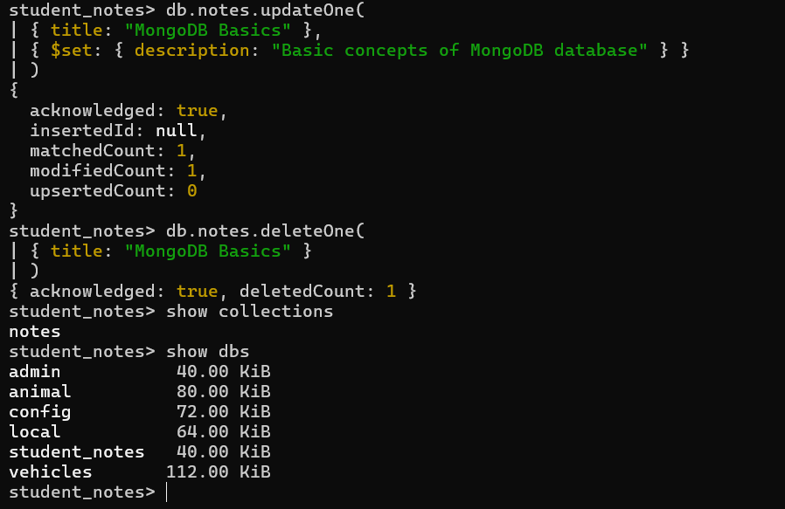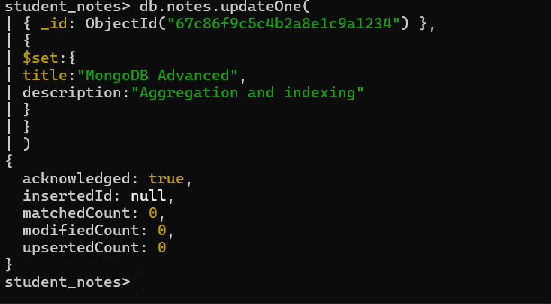

Question 2: Online Book Finder (Retrieval & Query Operations)
Develop a system where users can search, filter, and retrieve books using different MongoDB queries.
Modules
- Search Books by Title
- Filter Books by Category
- Sort Books by Price or Rating
- Display Top Rated Books
- Pagination (Load More)
Database Structure
Collection: books
Example document:
{
"_id":"ObjectId",
"title":"JavaScript Essentials",
"author":"John Smith",
"category":"Programming",
"price":450,
"rating":4.5,
"year":2023
}

Functional Requirements
1. Search Books by Title
AJAX request:
GET /books/search?title=javascript
MongoDB query:
db.books.find({title:{$regex:"javascript",$options:"i"}})
Returns JSON results.
2. Filter Books by Category
AJAX request:
GET /books/category/programming
MongoDB query:
db.books.find({category:"Programming"})
3. Sort Books
Sort by price.
AJAX request:
GET /books/sort/price
MongoDB query:
db.books.find().sort({price:1})
Sort by rating.
db.books.find().sort({rating:-1})
4. Top Rated Books
AJAX request:
GET /books/top
MongoDB query:
db.books.find({rating:{$gte:4}}).limit(5)
5. Pagination
AJAX request:
GET /books?page=2
MongoDB query:
db.books.find()
.skip(5)
.limit(5)
